**Core Java**

**MultiThreading concepts**

1. Introduction – What is Multithreading what is multitasking – basic Introduction
2. How many ways we can define a thread

By Extending thread class

By Implementing runnable interface

1. Getting and Setting name of thread
2. Thread priority
3. The methods to prevent thread execution
4. Yield
5. Join
6. Sleep
7. Synchronization
8. Inter thread communication
9. Wait
10. Notify
11. notifyall
12. Deadlock
13. Demon ThreadsMultithreading enhancements
14. Thread group
15. Thread local
16. MultiThreading enhancements
17. **Introduction**

Executing several task simultaneously is called Multitasking

It is divided into two parts

1. **Process based multitasking**
2. **Thread based multitasking**

**i., Process Based Multitasking**

Executing several task simultaneously where each task is separate independent program or process is called process based multitasking

**Example**: This type of multitasking only applicable only at **OS level**

Typing a Java program in the editor

We can Listen audio songs from the same system

At the same time we can Download a file from net

All these task will be executed simultaneously and independent of each other. Hence it is process based multitasking.

**ii., Thread Based Multitasking**

Executing several task simultaneously where each task is separate independent part of same program. This type of multitasking is called as thread based multitasking and each independent part is called a thread.

Thread based multitasking is best suitable at programmatic level.

**Example**

For example there are 1000 lines of code where there are two parts where first 500 lines of code is independents and one functionality and other 500 is other functionality we can make two threads from them.

**Advantage:**

1. To increase performance by reducing response time.
2. To reduce idle time of the processor
3. Performance will be improved
4. Whether it is process based or thread based the main objective of multitasking is to reduce response time of the system and to improve performance.

To develop webservers or application servers etc. where we can use multithreading concept.

Developing multithreaded applications in java is very easy because Java provides inbuilt support for multithreading with rich API (thread, thread group, runnable)

**Defining a Thread**

Thread is separate flow of execution. For every flow of execution there is some job is there.

We can define a thread in following two ways:

1. By extending thread class
2. By implementing runnable interface

**1. By Extending Thread class**

class MyThread extends Thread **{// Defining a thread**

public void run(){ **//Job of thread**

for (int i=0;i<10;i++){

Sysout(“child Thread”);

}

}

}

Class ThreadDemo{

P s v m(String[] args){ //Main thread

MyThread t = new Mythread(); **//Main thread creates child thread object**

t.start(); **//Main thread start child thread**

**//Child thread is responsible to execute run method. //Now we have two thread main thread and child thread**

for(int i=;i<10;i++){ **//executed by main thread**

sop(“Main thread”);

}

}

}

In the above program we have two threads:

1. **Main thread** – creates thread object and starts child thread.
2. **Child thread**

**Case 1: Thread scheduler**

It is the part of JVM. It is responsible to schedule threads that is if multiple threads are waiting to get the chance of execution then in which order threads will be executed is decided by thread scheduler.

We can’t expect exact algorithm followed by thread scheduler it is varied from JVM to JVM. Hence we can’t expect threads execution order and exact output. Hence whenever situation comes to multithreading there is no guarantee for exact output but we can provide several possible outputs

The following are various possible outputs for the above program.

P1

Mian thread

Main thread

-

-Child thread

Child thread

P2

Child Thread

Child Thread

-

-

Main Thread

Main Thread

P3

Main Thread

Child Thread

Main Thread

Child Thread

P4

Child Thread

Main Thread

Child Thread

**Case 2 – Difference between t.start( ) and t.run()**

If I do **t.start()** then there are two threads

If I do **t.run()** there only one thread first main thread will execute run method as normal method

Child Thread

Child Thread

-

-

Main Thread

Main Thread

Total execution done by Main thread. We will get everytime only one output.

In case of t.start() a new thread will be created which is responsible for the execution of run method.

But in case of t.run() a new thread won’t be created and run method will be executed just like a normal method call by main thread.

Hence in the above program if we replace t.start() with t.run() then the output is

Child Thread

Child Thread 10 times

--

Main Thread

Main Thread 10 times

This total output produced by only main thread.

**Implementing Thread using Runnable Interface**

We can implement Thread concept if one class implements Runnable interface

MyRunnable r = new MyRunnable();

Thread t1 = new Thread();

Thread t2 = new Thread(r);

**Case 1: t1.start();**

New Thread will be created and that thread is responsible to execute Thread class run() method which has empty implementation and we will not get any output.

**Case 2: t1.run();**

New Thread will not be created because we are directly calling Thread class run() method and run() method will be executed as a normal method.

**Case 3: t2.start();**

A new thread will be created and myRunnable run method will be executed

**Case 4:t2.run();**

New thread will not be created and MyRunnable run method will be executed just like a normal method call.

**Case 5: r.start()**

**Compile Time error saying “Cannot find symbol method start() in class MyRunnable”**

MyRunnable class doesn’t have start capability.

**Case 6: r.run()**

No new thread will be created. MyRunnable run method will be executed as a normal method.

**Which approach is recommended to define a thread**

Class MyThread extends Thread{

run() {

}

}

If we do this approach if we extend one class we can extend other class so we are missing inheritance benefit.

Class MyRunnable implements Runnable{

@Overrride

Run(){

}

}

In the above approach we can extends other class while implementing Runnable interface so we have benefit of having inheritance.

**Thread class constructors**

1. Thread t = new Thread();
2. Thread t = new Thread(Runnable r)
3. Thread t = new Thread(String name)
4. Thread t = new Thread(Runnable r, String name)
5. Thread t = new Thread(ThreadGroup g, String name)
6. Thread t = new Thread(ThreadGroup g, Runnable r)
7. Thread t = new Thread(ThreadGroup g, Runnable r)
8. Thread t= new Thread(ThreadGroup g, Runnable r, String name, long StackSize);

MyThread🡪 Thread 🡪 Runnable(I)

Class MyThread entends Thread{

Public void run() {

Sop(“Child Thread”);

}

}

Class ThreadDemo{

Psvm(String[] args){

MyThread t = new MyThead();

Thread t1 = new Thread();

T1.start();

Sop(“main Thread”);

}

}

o/p: Child Thread

Main Thread

Class MyThread extends Thread{

}

Class Test{

P s v m(String[] args){

Sopln(Thread.currentThread().getName()); //**main**

MyThread t = new MyThread();

Sopln(t.getName()); //**Default name – Thread-0**

**Thread.getCurrentThread().setName(“pawan kaylan”);**

MyThread t = new MyThread();

Sopln(t.getName()); //**Default name – Pawan Kalyan**

}

}

**Getting and Setting Name of a Thread**

Every thread in java has some name, it maybe default name generated by JVM or customized name provided by programmer.

Public final String getName()

Public final void setName(String name)

**Thread Priorities**

Thread.MIN_PRIORITY = 1

Thread.NORM_PRIORITY = 5

Thread.MAX_PRIORITY = 10

Every thread in java have some priority, it maybe default priority generated by JVM or customized priority provided by programmer.

The valid range of thread priorities is 1 to 10, where 1 is min priority and 10 is max priority. Thread class defines the following constants to represents some standards priorities.

Thread.MIN_PRIORITY = 1

Thread.NORM_PRIORITY = 5

Thread.MAX_PRIORITY = 10

Thread scheduler will use priorities while allocating processors. The thread which is having the highest priorities will get the chance first.

If two threads are having same priorities then we can’t expect exact execution order it depends on thread scheduler (It may be first come first, round robin based)

If we give thread priority any large value. We will get exception like Allowed values range: 1 to 10 or runtime exception RE: IllegalArgumentException

Eg . t.setPriority(7) – This is valid

t.setPriority(17) – RE: IllegalArgumentException

Public final int getPriority()

Public final void setPriority(int P)

**Default Priority**

Default priority only for main thread is 5.

But for all remain thread default priority will be inherited from Parent to Child.

Whatever the priority the Parent thread has the same priority will be there for the child thread.

**package** JavaConcepts;

**class** MyThread4 **extends** Thread{

**public** **void** run() {

**for**(**int** i=0;i<10;i++){

System.***out***.println("child Thread");

}

}

}

**public** **class** ThreadPriority2 {

**public** **static** **void** main(String[] args) {

MyThread4 t = **new** MyThread4();

t.setPriority(10); - 1

t.start();

**for**(**int** i=0;i<10;i++){

System.***out***.println("Main Thread");

}

}

If we comment line 1 then main thread and child thread will have same priority then we can’t expect exact execution order and output

If we are not commenting line 1 then main thread has the priority 5 and child thread has a priority 10 hence child thread will get the chance first followed by main thread.

In this case output is child thread (10 times) and main thread (10 times)

Some platform won’t have proper support for thread priorities.

**Preventing Thread Execution**

1. Yield method
2. Join method
3. Sleep method

By using above three methods we can prevent thread execution.

**Yield**

Yield method causes to pause current executing thread to give the chance for waiting threads of same priority.

If there is no waiting thread or all waiting threads have low priority then same thread can continue its execution.

If multiple threads are waiting with same priority then which waiting thread will get the chance we can’t expect it depends on thread scheduler.

The thread which is yielded when it will get the chance once again it depends on thread scheduler and we can’t expect exactly.

If there is no waiting thread or thread having low priority then the same thread can continue.

**Public static native void yield();**

A native method is a Java method (either an instance method or a class method) whose implementation is also written in another programming language such as C/C++. Moreover, a method marked as native cannot have a body and should end with a semicolon: [ public | protected | private] native [return_type] method ();

**Life cycle of Thread**

**New/Born state – Thread t = new Thread();**

**Ready/Runnable state – t.start();**

**Running state - If Thread scheduler allocates processor**

**Dead state - If run() method completes**

**If running method suddenly calls yield() method then thread goes from running state to ready state.**

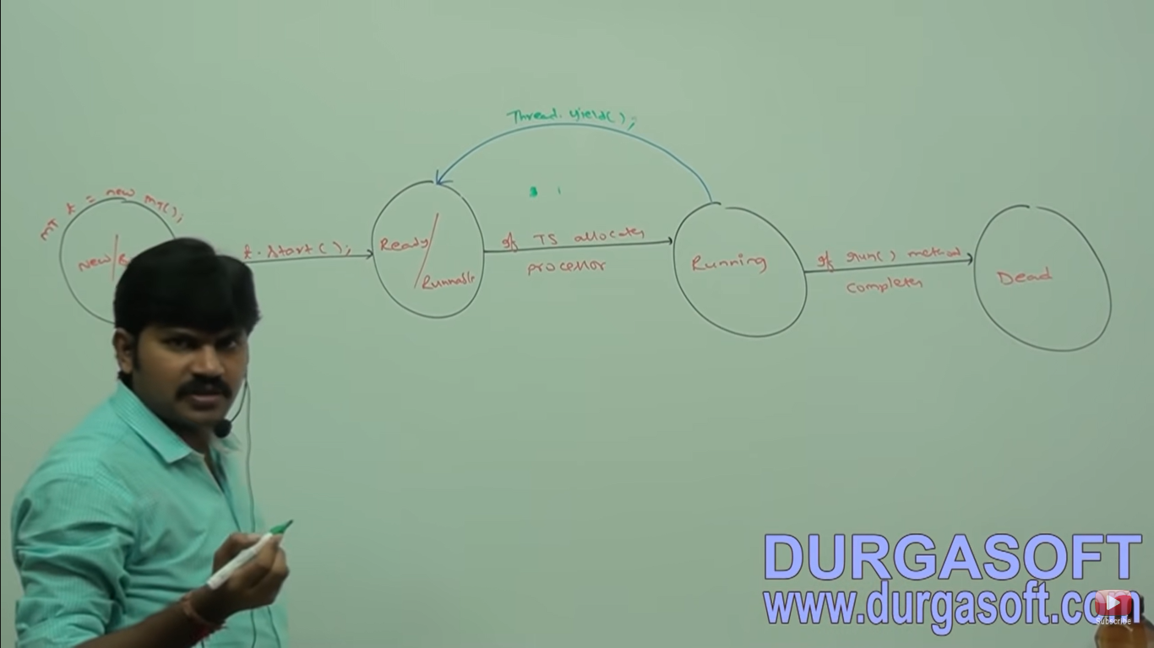

**package** JavaConcepts;

**class** Mythread5 **extends** Thread{

**public** **void** run() {

**for**(**int** i=0;i<10;i++) {

System.***out***.println("Child Thread");

//Thread.yield(); - 1

}

}

}

**public** **class** MultiThreadingYieldDemo {

**public** **static** **void** main(String[] args) {

Mythread5 t = **new** Mythread5();

t.start();

**for**(**int** i=0;i<10;i++) {

System.***out***.println("Main Thread");

}

}

}

**In the above program if we are commenting line 1 then both the threads will be executing simultaneously and we can’t expect which thread will complete first if we are not commenting line 1 then child thread always calls yield method because of that main thread will get the chance more number of times and the chance of completing main thread first is high.**

**Some platform won’t proper support for yield method.**

**Difference between yield() and join()**

**If a thread (t1) want to wait until the completing the execution for other thread(t2) then t1 should call join method. So ultimately t1 goes into wait state.**

**For eg: t1 has to call t2.join().**

**If t1 executes t2.join() then immediately t1 will be entered into waiting state until t2 completes. Once t2 completes then t1 can continue its execution.**

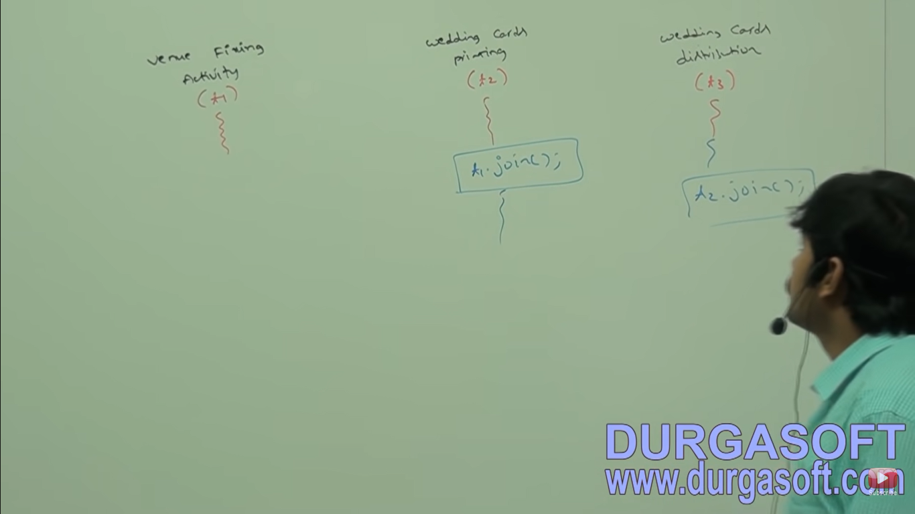

**Public final void join() throws interrupted Exception**

**Public final void join(long ms)throws interrupted Exception**

**Public final void join(long ms, int ns) throws interrupted Exception**

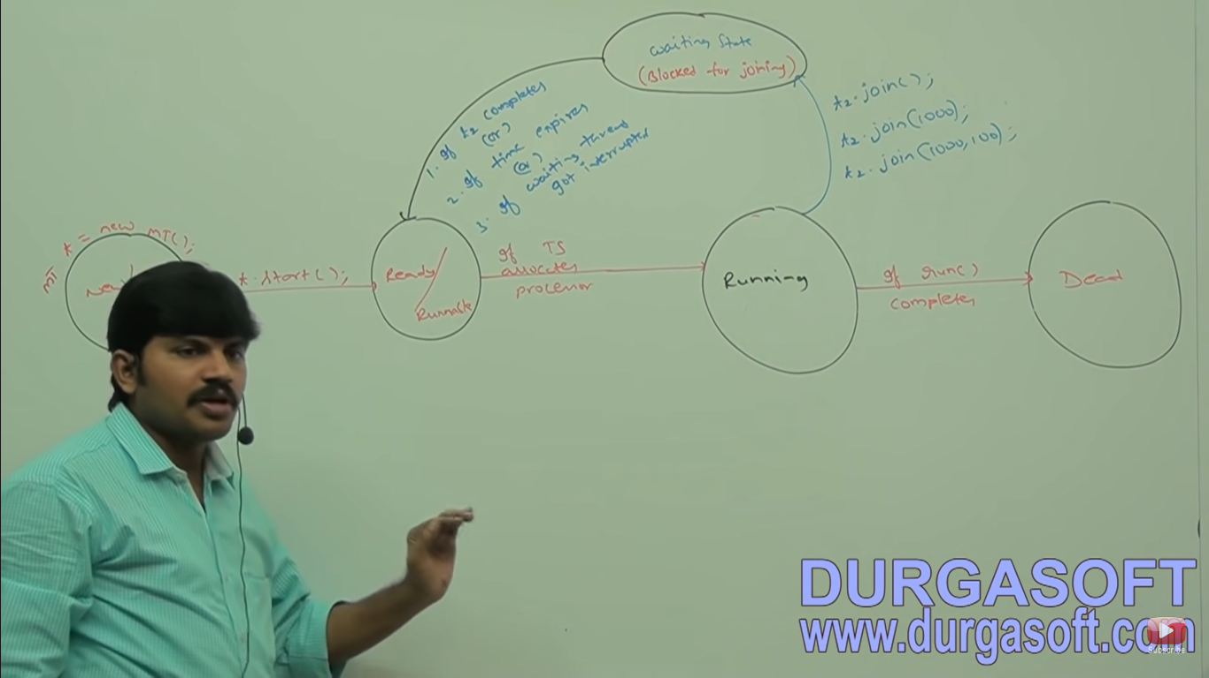

**If a thread calls joins method it wil come into waiting state.**

**It can come out of waiting state only if:**

1. **If t1 completes**
2. **If time expires**
3. **If waiting thread got interrupted**

**Case 3: Deadlock or Stuck for Thread**

**If main thread calls join method or child thread object and child thread calls join method or main thread object then both threads will wait forever and the program will be stucked (This is something like Deadlock)**

**Case 4: IF a Thread calls join method in the same thread itself then the program will stuck (This is something like Deadlock). In this case thread has to wait infinite amount of time.**

**Class Test{**

**Public static void main(String[] args) throws InterruptedException{**

**Thread.currentThread().join();**

**}**

**}**

**Sleep Method**

If a thread don’t want to perform any operation for a particular amount of time then we should go for sleep() method.

**Public static native void sleep(long ms) throws IE**

**Public static void sleep(long ms, int ns) throws IE**

Every sleep() method throws interrupted exception which is checked exception hence whenever we are using sleep() method compulsory we should handle interrupted exception either by try-catch or by throws keyword otherwise we will get compile time error.

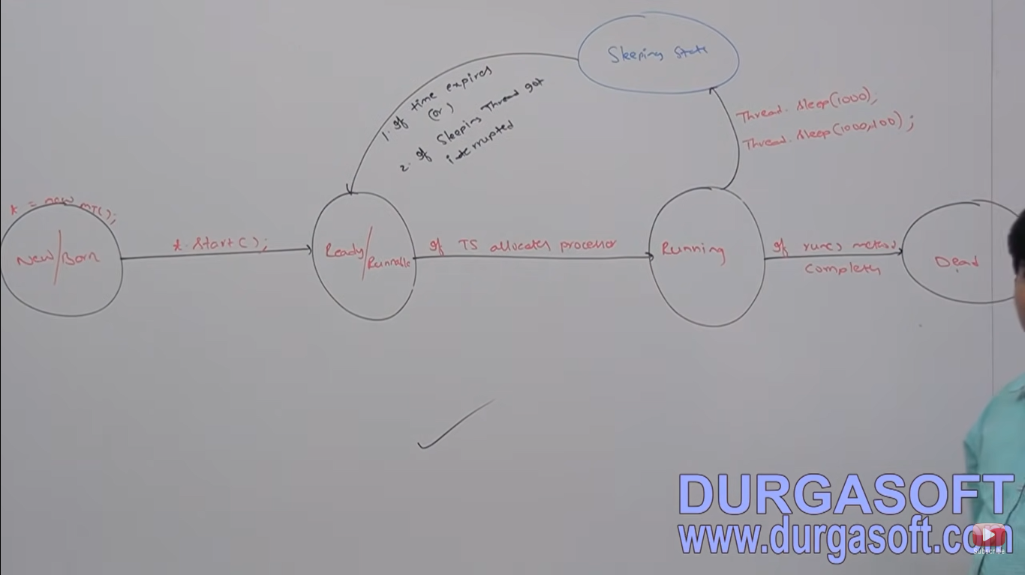

**Public void interrupt()**

**Sleep()**

**Wait()**

A thread can interrupt sleeping thread or waiting thread by using interrupt method of thread class

**package** JavaConcepts;

**class** MyThread20 **extends** Thread{

**public** **void** run() {

**try** {

**for**(**int** i=0;i<10;i++) {

System.***out***.println("I am Lazy Thread");

Thread.*sleep*(2000);

}

}**catch**(InterruptedException e) {

System.***out***.println("I got interrupted");

}

}

}

**public** **class** InterruptThreadDemo {

**public** **static** **void** main(String[] args) {

MyThread20 t = **new** MyThread20();

t.start();

t.interrupt(); 🡪 1

System.***out***.println("End of main thread");

}

}

If we comment line 1 then main() thread won’t interrupt child thread. In this case child thread will execute for loop 10 times.

If we are not commenting line 1 then main() thread will interrupt child thread. In this case output is

**End of main thread**

**I am lazy thread**

**I got interrupted**

**package** JavaConcepts;

**class** MyThread20 **extends** Thread{

**public** **void** run() {

**for**(**int** i=0;i<10000;i++) {

System.***out***.println("I am Lazy Thread");

}

System.out.println(“I am entering into sleeping state”);

**try** {

Thread.*sleep*(2000);

}

**catch**(InterruptedException e) { System.***out***.println("I got interrupted"); }

}

}

**public** **class** InterruptThreadDemo {

**public** **static** **void** main(String[] args) {

MyThread20 t = **new** MyThread20();

t.start();

t.interrupt();

System.***out***.println("End of main thread");

}

}

Whenever we are calling interrupt() method if the target thread not in sleeping state or waiting state then there is no impact of interrupt() call immediately interrupt call will be waited until target thread entered into sleeping or waiting state. If the target thread entered into sleeping or waiting state then immediately interrupt call will interrupt the target thread.

If the target thread never entered into sleeping or waiting state in it’s lifetime then there is no impact of interrupt call this is the only case where interrupt call will be wasted.

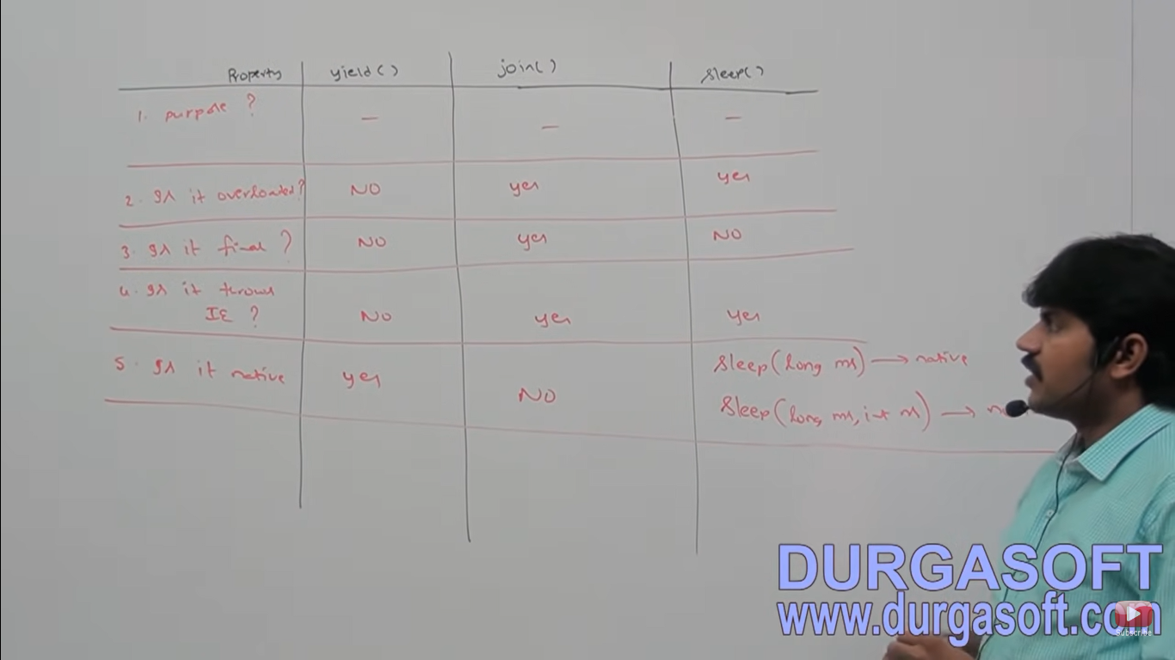

1. Purpose:

**Yield**- If a thread wants to pause its execution to give the chance for remaining threads of same priority then we should go for yield() method

**Join()** - If a thread wants to wait until completing some other thread then we should go for join() method

**Sleep() -** If a thread don’t want to perform any operation for a particular amount of time then we should go for sleep() method

1. Overloaded

Yield – no

Join – yes

Sleep – yes

1. **Final**

Yield – no

Join – yes

Sleep – no

1. **Throws IE**

Yield – no

Join – yes

Sleep – yes

1. **Native method**

Yield – yes

Join – no

Sleep – long(ms) – native

Long(ms, int ns) – non native

1. **Static**

Yield – yes

Join – no (all are instance on the object we have to call)

Sleep - yes

**Synchronized**

Synchronized is the modifier applicable only for methods and blocks but not for classes and variables.

If multiple threads are trying to operate simultaneously on the same Java object then there maybe a chance of data inconsistency problem. To overcome this problem we should go for synchronized keyword.

If a method or block declared as synchronized then at a time only one thread is allowed to execute that method or block on the given object so that data inconsistency problem will be resolved.

The main advantage of synchronized keyword is we can resolve data inconsistency problems but the main disadvantage of synchronized keyword is it increases waiting time of threads and creates performance problems. Hence If there is no specific requirement then it is not recommended to use synchronized keyword.

Internally synchronization is implemented by using lock. Every object in java has a unique lock.

Whenever we are using synchronized keyword then only lock concept will come into the picture.

If a thread wants to execute synchronized method on the given object first it has to get lock of that object once thread got the lock then it is allowed to execute any synchronized method on that object. Once method execution completes automatically thread releases lock. Acquiring and releasing internally take cares by JVM and programmer not responsible for this activity.

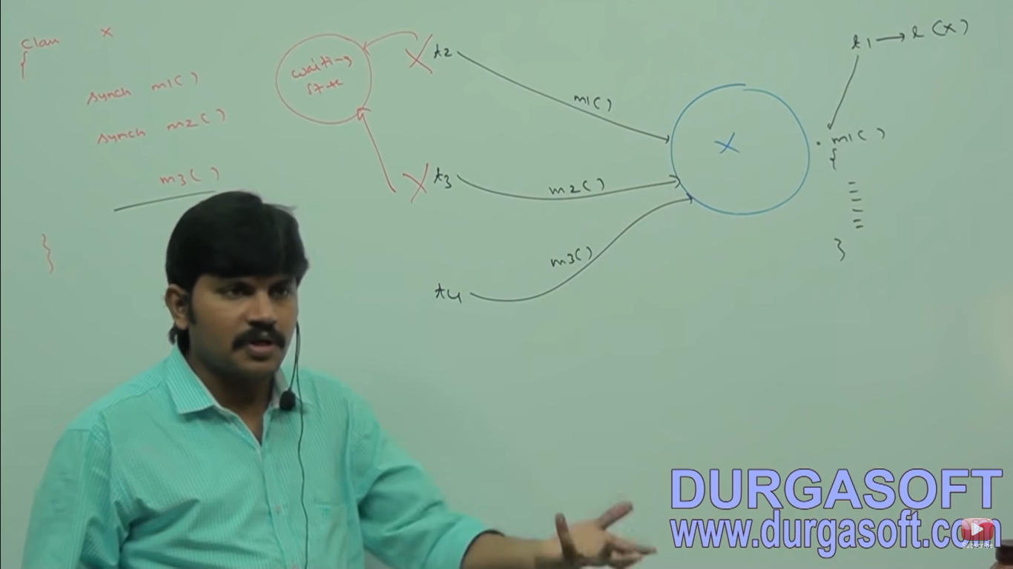

While a thread executing synchronized method on the given object the remaining threads are not allowed to execute any synchronized method simultaneously on the same object but remaining threads are allowed to execute non synchronized methods simultaneously.

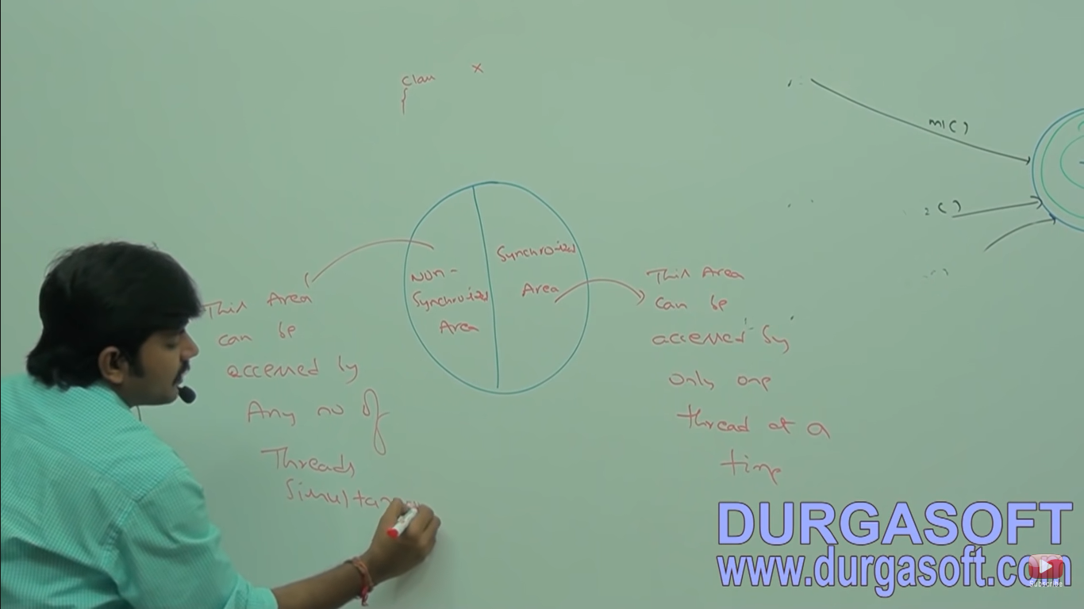

Non Synchronized – This area can be accessed by any number of thread simultaneously.

Synchronized – This area can be accessed only one thread at a time.

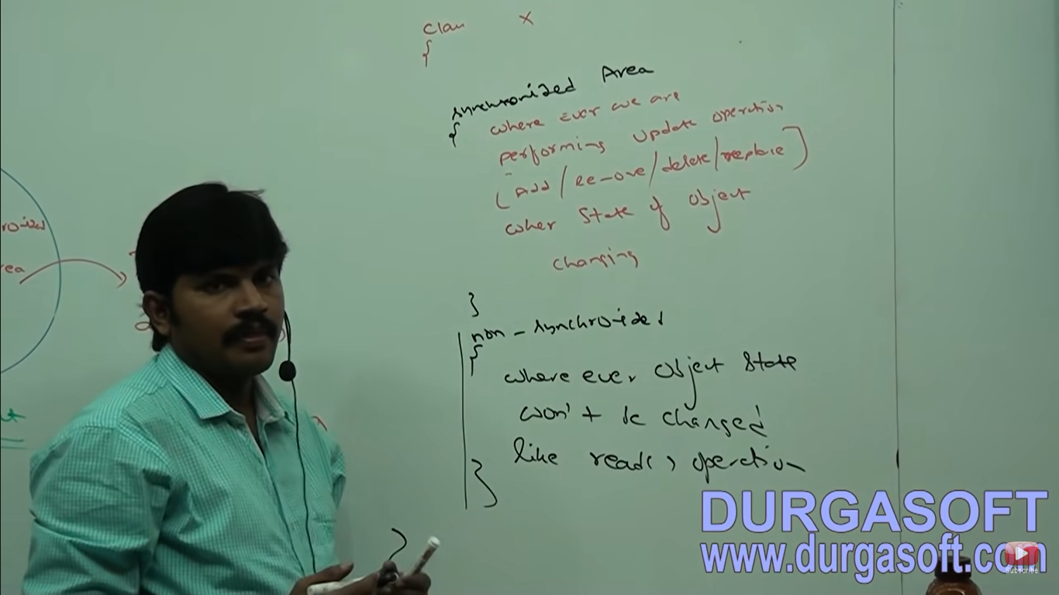

Wherever we are performing update operation (Add/remove/delete/replace) that is wherever state of object is changing then this area should be synchronized area

Wherever object of state won’t be changed like read operation.

For eg class reservation system check availability non synchronized

Book ticket – synchronized

**Case Study**

If multithread operating on multiple object then synchronization is not required but we will get irregular output.

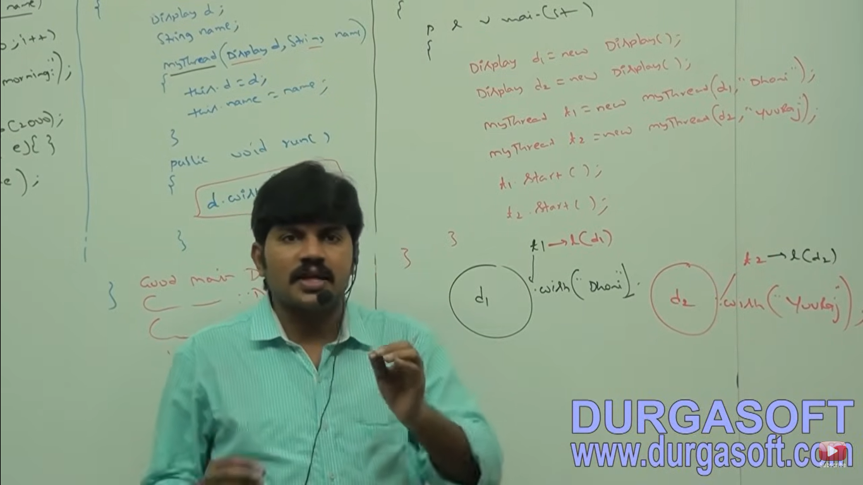

Even though wish method is synchronized we will get irregular output because threads are operating on different java objects.

**Using static keyword with Synchronized**

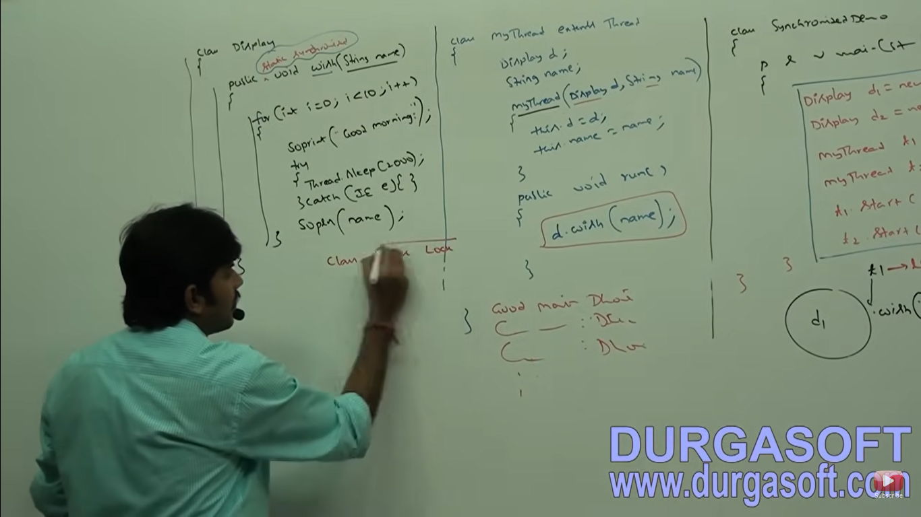

In java we have two level locks object level or class level lock

If we declare method as static synchronized we need class level lock.

**Class Level lock**

Every class in java has a unique lock which is also known as class level lock.

If a thread wants to execute static synchronized method then we require class level lock. Once a thread got class level lock then it is allowed to execute any static synchronized method of that class. Once method execution completes automatically thread releases the lock.

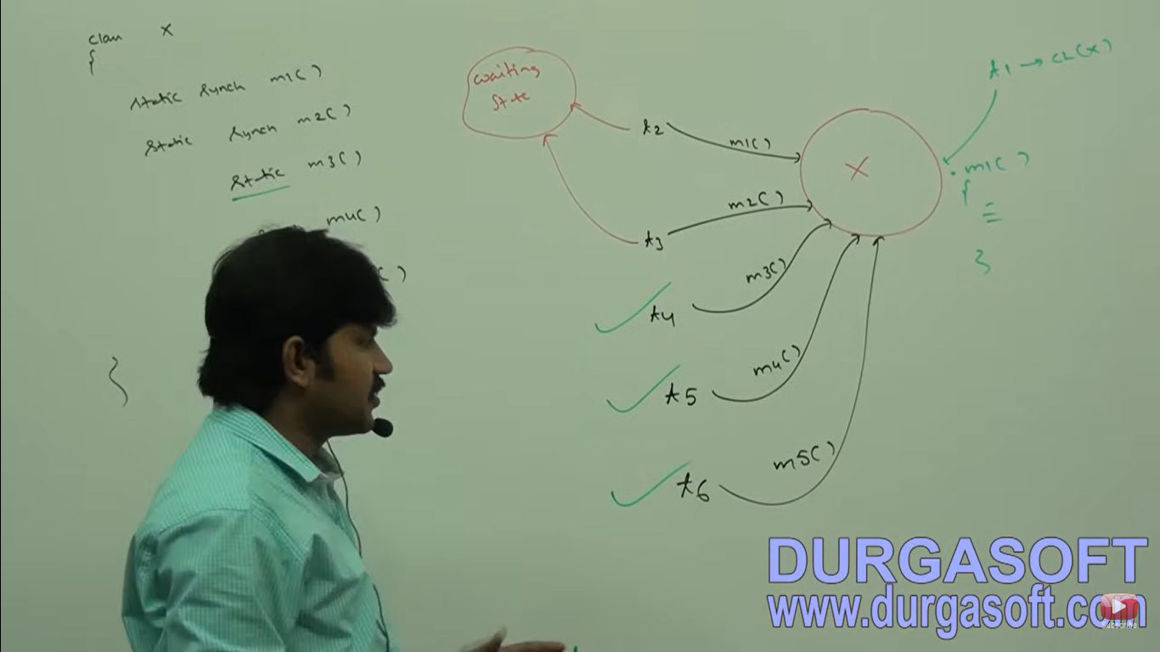

While a thread executing static synchronized method the remaining threads are not allowed to execute static synchronized method of that class simultaneously but remaining threads are allowed to execute the following methods simultaneously.

1. Normal static methods
2. Synchronized instance methods
3. Normal instance methods

If we have two threads but working on different methods of same class then we have irregular output since object is same but having different methods in the same class java object. Then we need to use synchronized keyword.

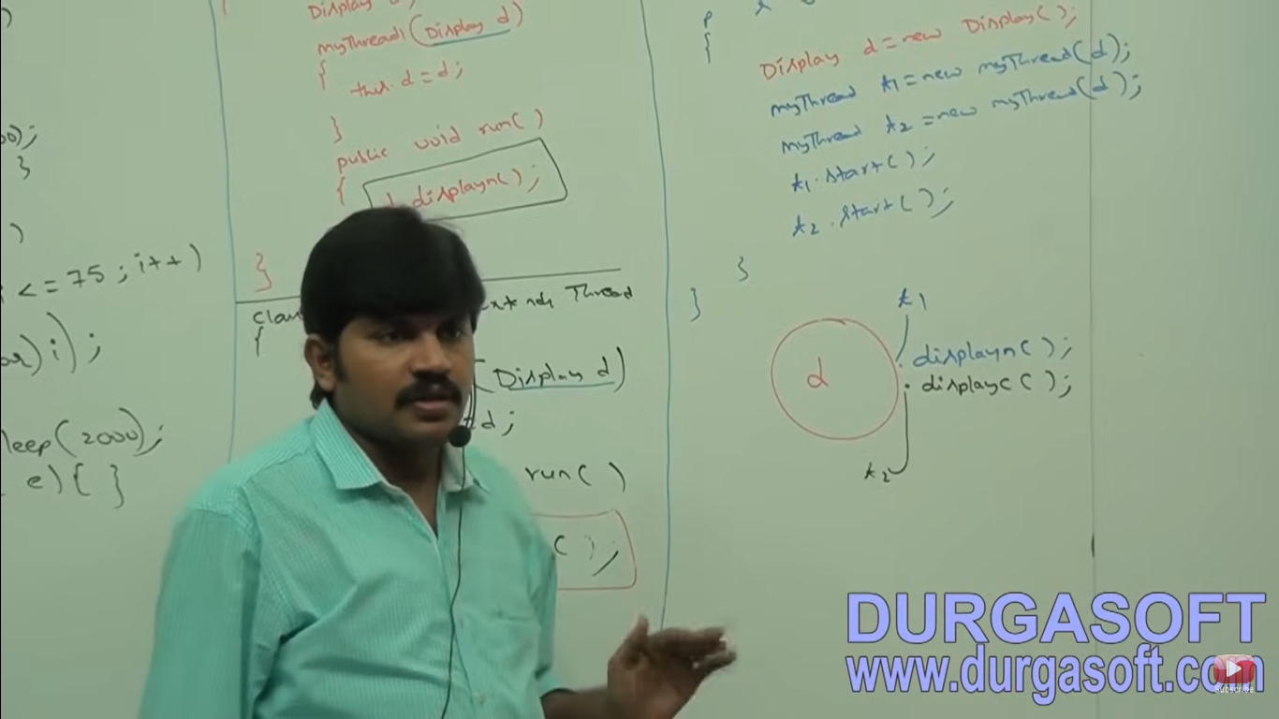

**Synchronized block**

If very few lines of the code requires synchronization then it is not recommended to declare entire method as synchronized we have to enclose those few lines of the code by using synchronized block.

The main advantage of synchronized block over synchronized method is it reduces waiting time of thread and improves the performance of the system.

**We can declare synchronized block as follows:**

1. **To get lock of current object**

Synchronized(this) {

}

If a thread got lock of current object(this) then only it is allowed to execute this area.

**2) To get lock of particular object b**

Synchronized(b){

}

If a thread got lock of particular object b then only it is allowed to execute this area.

**3) To get class level lock**

Synchronized(Display.Class) {

}

If a thread got class level lock of Display class, then only it is allowed to execute this area.

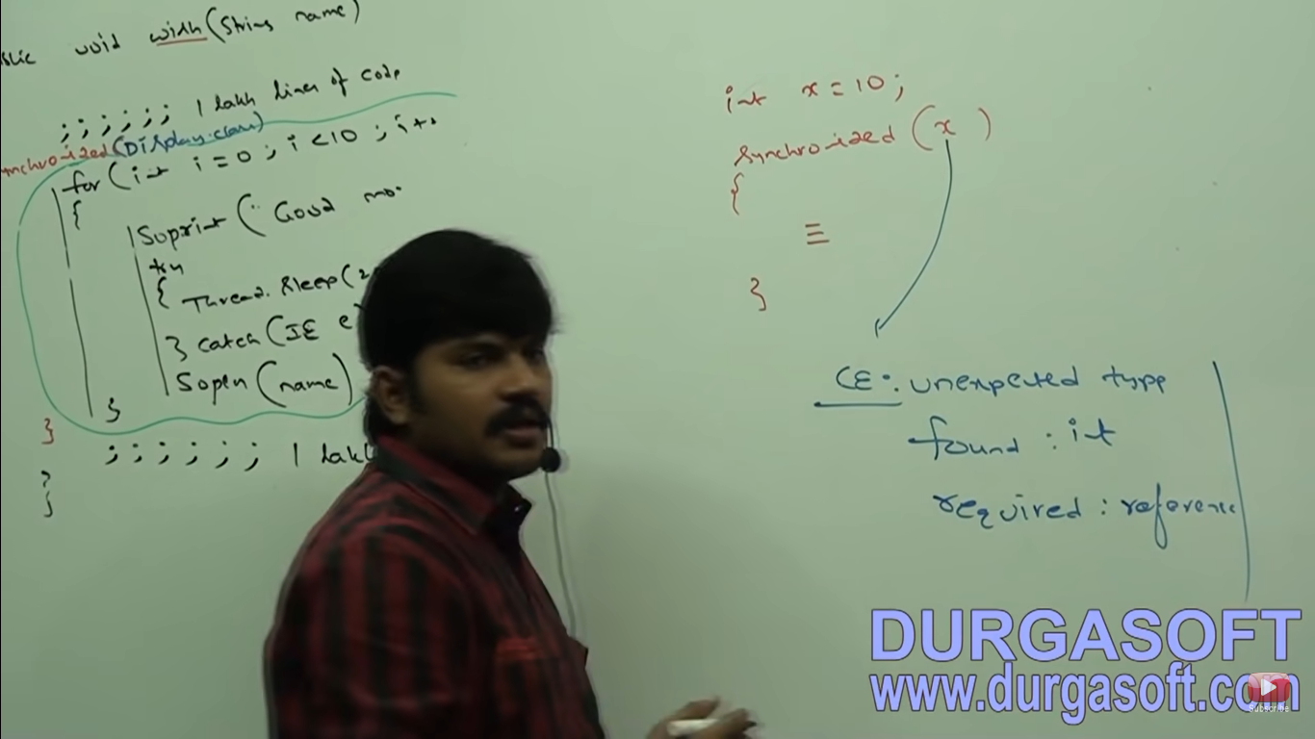

Lock concept applicable for object types and class types but not for primitives hence we can’t pass primitive type as argument to synchronized block otherwise we will get compile time error saying **unexpected type found int required reference**

**If multiple thread operating simultaneously then there may be chance of data inconsistency problem this is called as race condition. This can be avoided by using synchronized keyword.**

**InterThread Communication**

Two threads can communicate with each other by using wait(), notify() and notifyAll() methods. A thread which is expecting updation is responsible to call wait method then immediately thread will enter into waiting state. The thread which is responsible to perform updation, after performing updation it is responsible to call notify() method then waiting thread will get the notification and continue its execution with those updated items.

Wait(), notify(), notifyAll() methods present in object class but not in thread class.

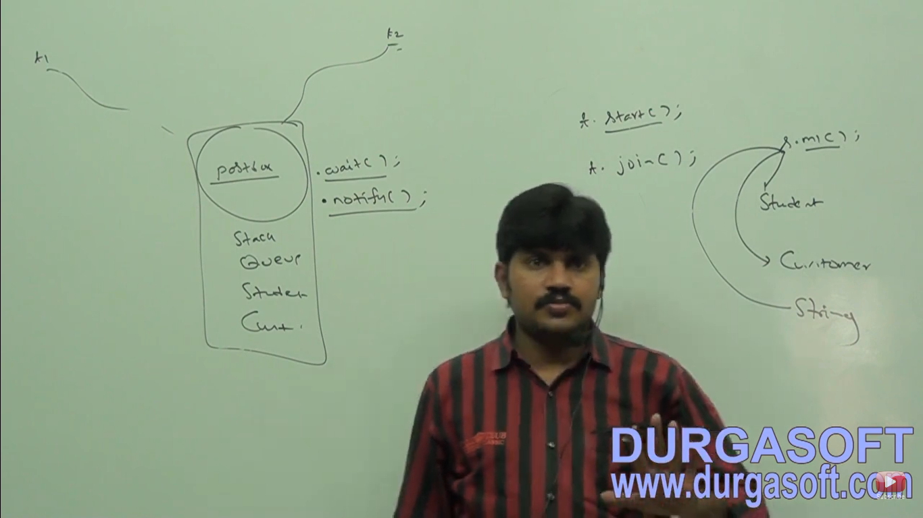

Wait(), notify() and notifyAll() methods present in object class but not in Thread class because thread can call these methods on any Java Object.

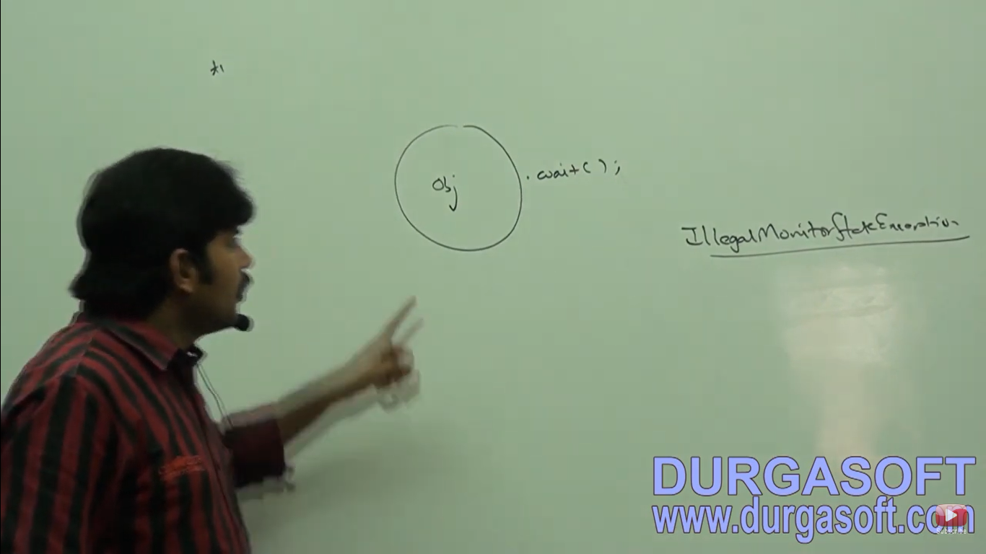

To call wait(), notify() and notifyAll() methods on any object, thread should be owner of that object that is the thread should has lock of that object that is the thread should be inside synchronized area.

Hence we can call wait(), notify() and notifyAll() methods only from synchronized area otherwise we will get runtime exception saying **IllegalMonitorStateException.**

If a thread calls wait() method on any object it immediately release the lock of that particular object and entered into waiting state.

If a thread calls notify() method on any object it releases the lock of that object but may not immediately except wait(), notify() and notifyALl() there is no other method where thread releases the lock.

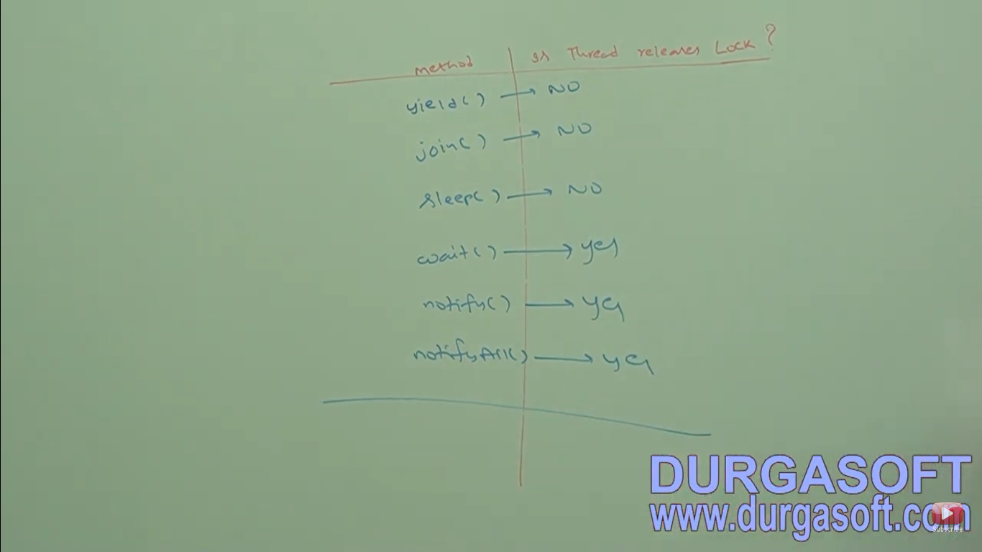

Yield – no releases of lock

Join() – no releases of lock

Sleep() – no releases of lock

Wait() – yes release of lock

Notify() – yes release of lock

notifyAll() – yes releases of lock

1. If a Thread calls wait() method immediately it will enter into waiting state without releasing any lock. – invalid
2. If a thread calls wait() method it releases the lock of that object but may not immediately – invalid
3. If a thread calls wait() method on any object it releases all locks acquired by that thread and immediately entered into waiting state. – **invalid**
4. If a thread calls wait() method on any object it immediately releases the lock of that particular object and entered into waiting state – **valid**
5. If a thread calls notify() method on any object it immediately release the lock of that particular object – **invalid**
6. If a thread calls notify() method on any object it releases the lock of that object but maynot immediately – **valid**

Public final void wait() throws IE **– wait until get notification**

Public final native void wait (long ms) throws IE– **wait for some time eg 1 hr if not get notification then will continue execution**

Static final void wait(long ms , int ns) throws IE – wait method is overloaded,

**No waiting state for notify() and notifyAll() so it will not throw IE.**

Public final native void notify()

Public final native void notifyAll()

Notify() and notifyAll() method are all native but not all wait() is not native method

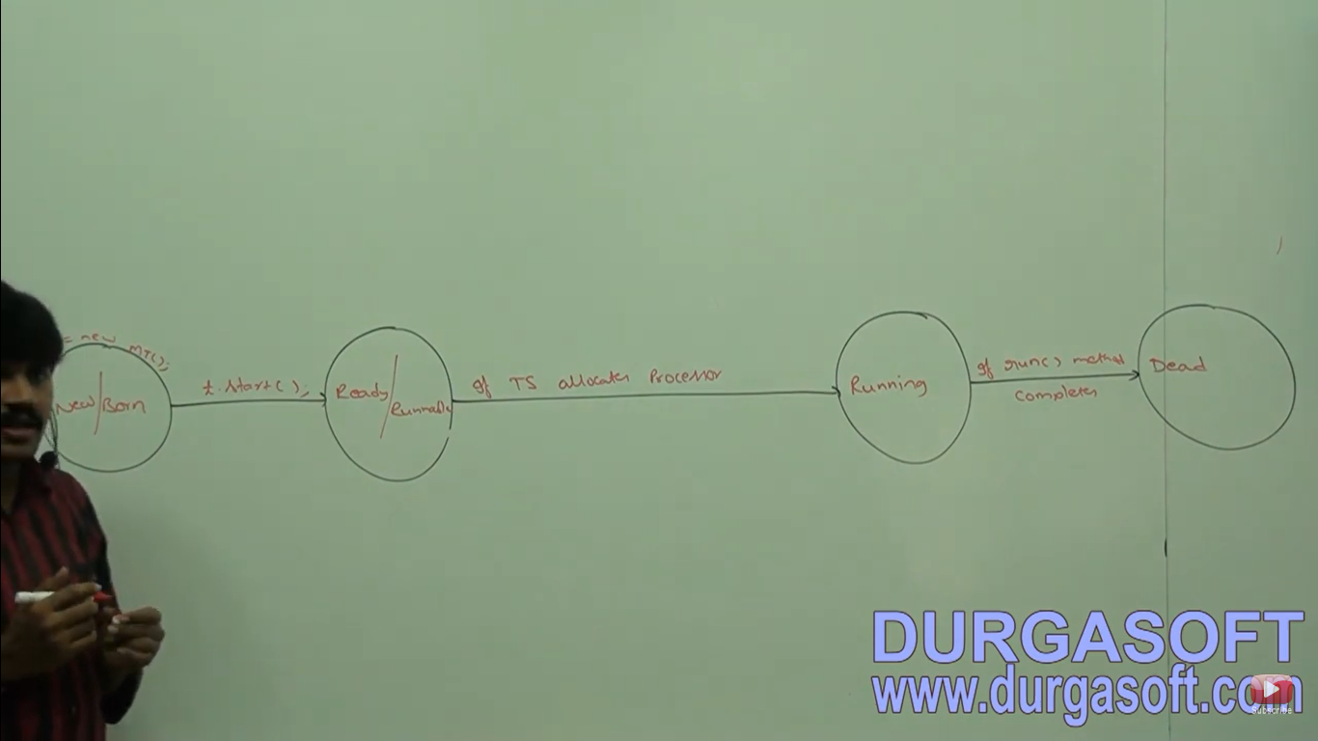

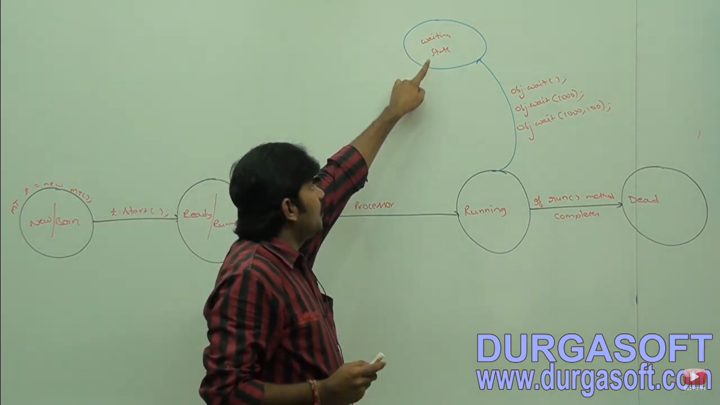

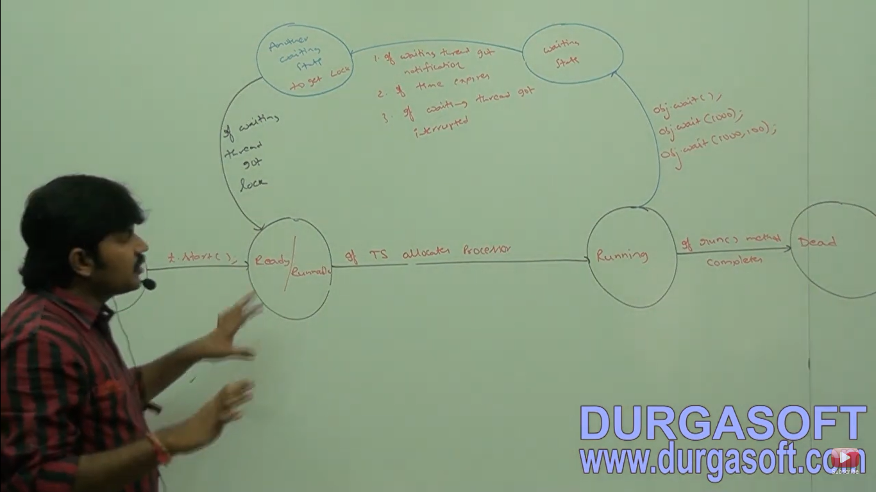

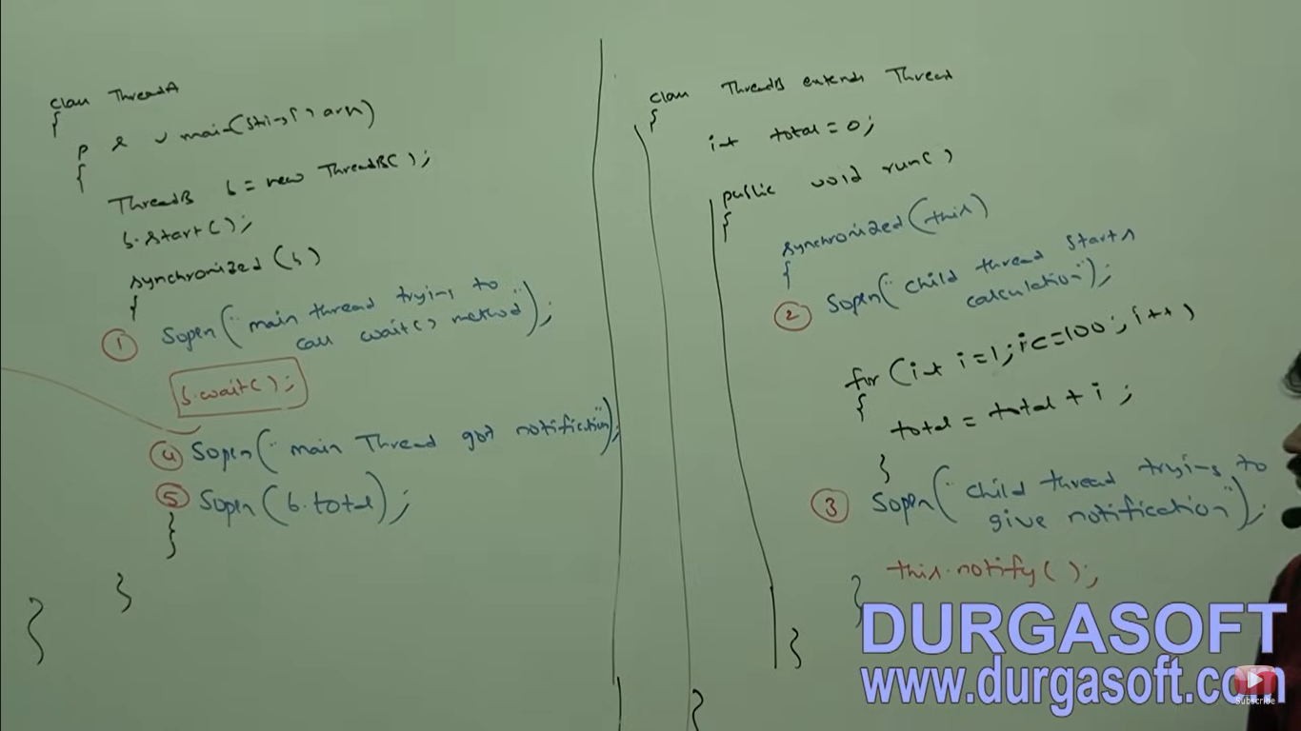

**Producer/Consumer example for Interthread communication**

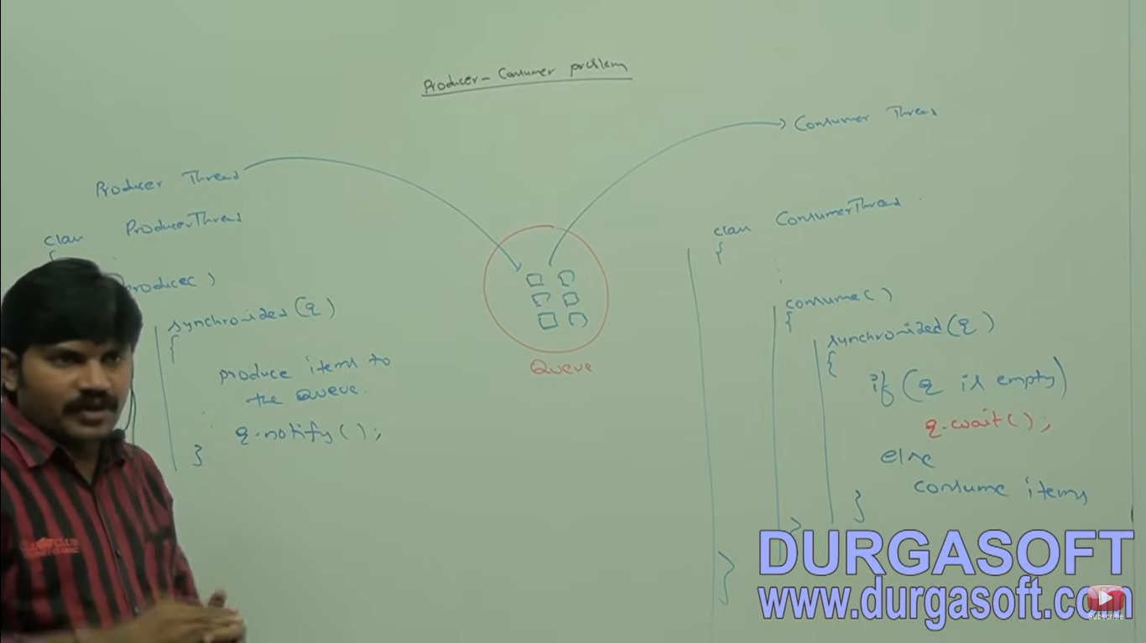

Producer thread is responsible to produce items to the queue and consumer thread is responsible for consuming items from the queue. If q is empty then consumer thread will call wait method and enter into waiting state. After producing items to the queue producer thread is responsible to call notify method then waiting consumer will get that notification and continue it’s execution with updated items.

**Difference between notify() and notifyAll()**

We can use notify() method to give the notification for only one waiting thread. If multiple threads are waiting then only one thread will be notified and the remaining threads have to wait for further notifications which thread will be notified we can’t expect it depends on JVM.

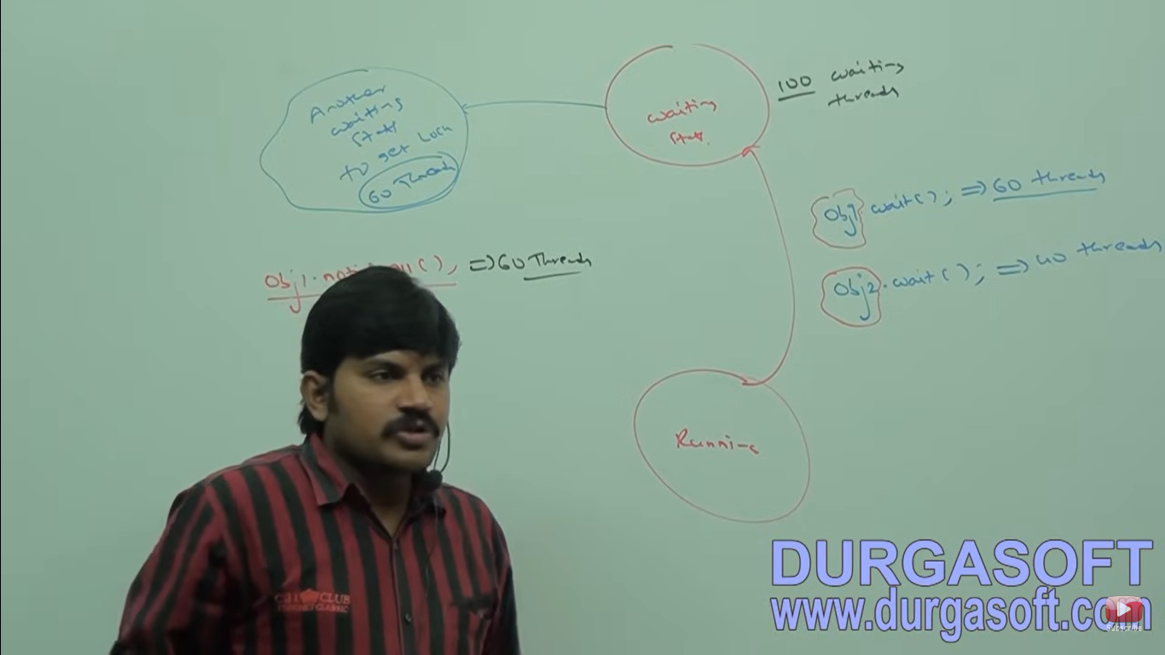

We can use notifyAll()to give the notification for all waiting threads for a particular object even though multiple threads notified but execution will be performed one by one because threads required lock and only one lock is available.

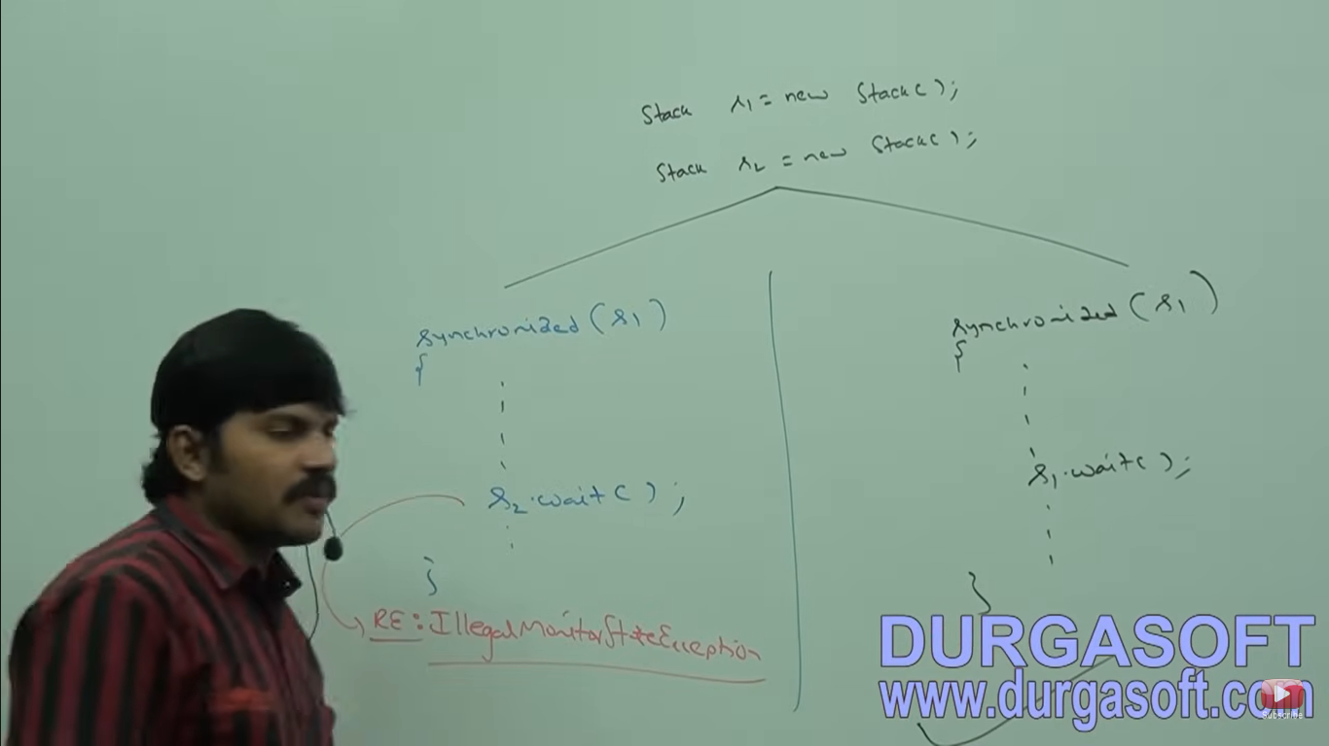

On which object we are calling wait() method thread require lock of that particular object. For eg: If we are calling wait() method on s1 then we have to call wait() method on s1 but not on s2.

**Deadlock**

If two threads are waiting for each other forever such type of infinite waiting is called Deadlock.

Synchronized keyword is only reason for deadlock situation hence while using synchronized keyword we have to take special care.

There are no resolution techniques for deadlock but several prevention techniques are available

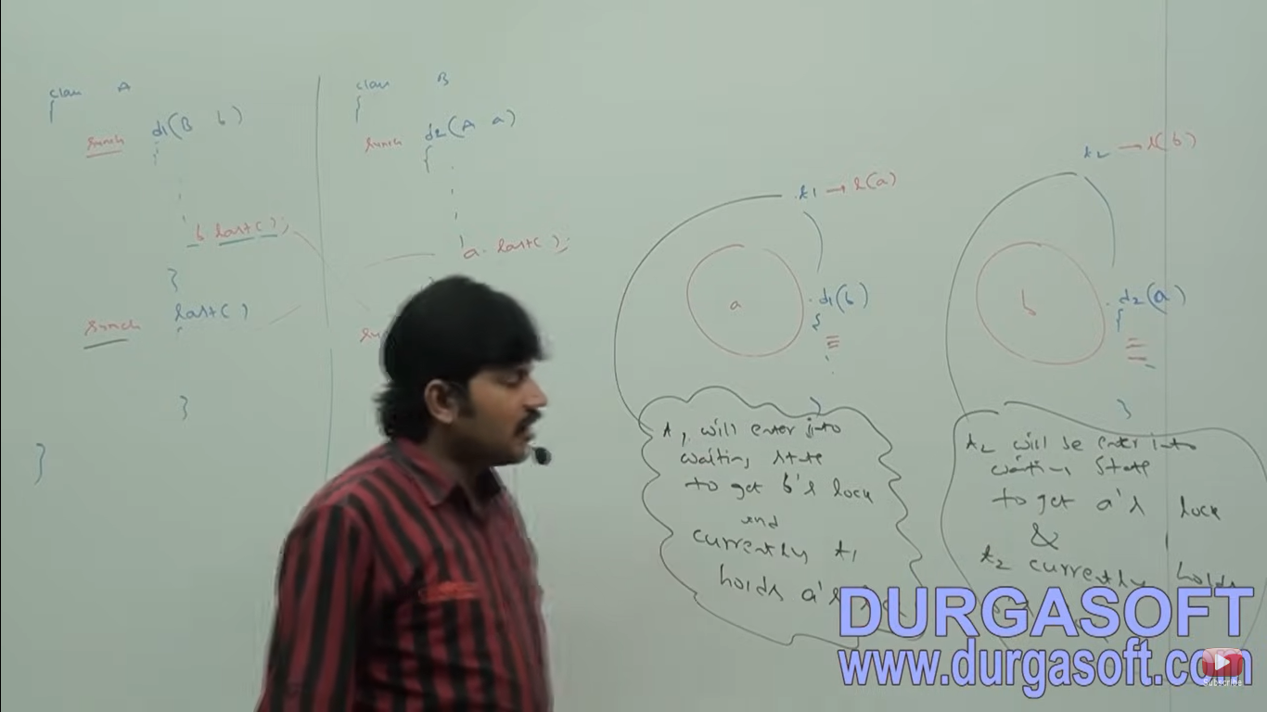

In the above program if we remove at least one synchronized keyword then the program won’t entered into deadlock. Hence synchronized keyword is the only reason for deadlock situation. Due to this while using synchronized keyword we have to take special care. Long waiting of thread where waiting never ends such type of waiting is Deadlock situation.

**Starvation** – Long waiting of thread but waiting ends at some point of time it is called as starvation. For eg 1 crore threads are there where 1 thread is having priority 1 but remaining threads are having priority 10 then in this situation priority 1 thread will have to wait.

**Daemon Threads**

The threads which is executing in the background are called as daemon thread. For eg garbage collector, attached listener, signal dispatcher.

The main objective of daemon threads is to provide support for non daemon threads (main thread). For eg if main thread runs with low memory then JVM runs garbage collector to destroy useless objects so that number of bytes of free memory will be improved with this free memory main thread can continue it’s execution.

Usually daemon threads having low priority (1) but based on our requirement daemon threads can run with high priority (10) also.

**How to check if thread is daemon or not**

Public boolean isDaemon()

Public void setDaemon(Boolean b)

We can check daemon nature of a thread by using isDaemon() of thread class.

We can change daemon nature of a thread by using setDaemon() method.

But changing daemon nature is possible before starting of a thread only after starting a thread if we are trying to change daemon nature then we will get runtime exception saying **IllegalThreadStateException.**

**Default nature of a thread**

By default main thread is non daemon. For other thread the default nature is inheriting from parent to child.

That is if the parent is thread is daemon then automatically child thread is also daemon. And if the parent thread is non daemon then automatically child thread is also non daemon.

**Note:**

It is impossible to change daemon nature of main thread because Main thread is already started by JVM at beginning so we cannot make Main thread as daemon.

Class Test{

P s v m(String[] args){

Sop(Thread.currentThread().isDaemon()); //false

Thread.currentThread.setDaemon(); 🡪RE: **IllegalThreadStateException**

**myThread t = new mythread();**

**sop(t.isDaemon()); //false**

**t.setDaemon(true);**

**sop(t.isDaemon()); //true**

}

}

Whenever last non daemon thread terminates automatically all daemon threads will be terminated irrespective of their position.

**package** JavaConcepts;

**class** MyThread19 **extends** Thread{

**public** **void** run() {

**for**(**int** i=0;i<10;i++) {

System.***out***.println("Child Thread");

**try** {Thread.*sleep*(2000);}**catch**(InterruptedException e) {}

}

}

}

**public** **class** DaemonThreadDemo2 {

**public** **static** **void** main(String[] args) {

MyThread19 t = **new** MyThread19();

t.setDaemon(**true**);

t.start();

System.***out***.println("end of main thread");

}

}

**Green Thread**

The thread which is managed completed by JVM without underlying **OS support** such type of thread is known as Green thread model. This is deprecated not recommended to use. This is supported by very few OS like sun solaris

**Native Os Model**

In addition to JVM underlying OS support also is required. The Thread lifecycle is also managed by JVM with the help of underlying OS.

Java multithreading concept is implemented by using two following models:

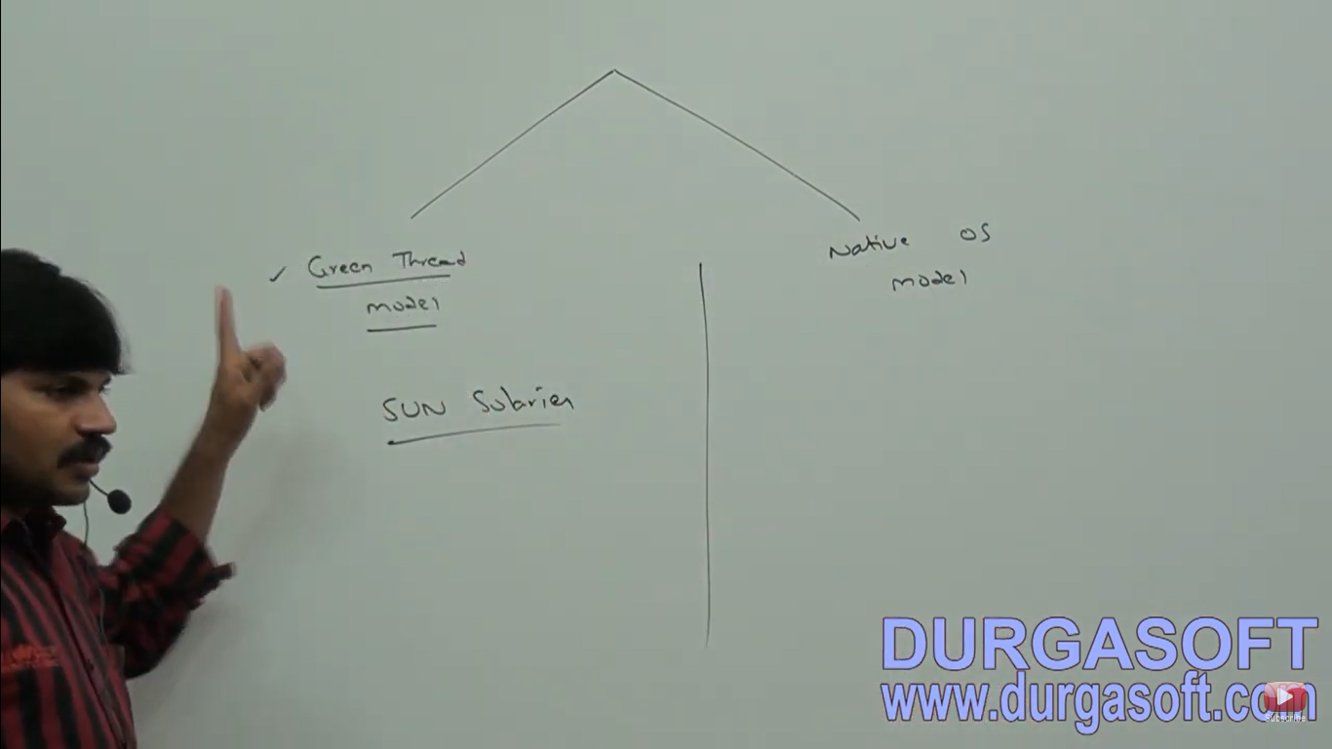

1. Green thread model
2. Native OS Model

**How to stop a thread**

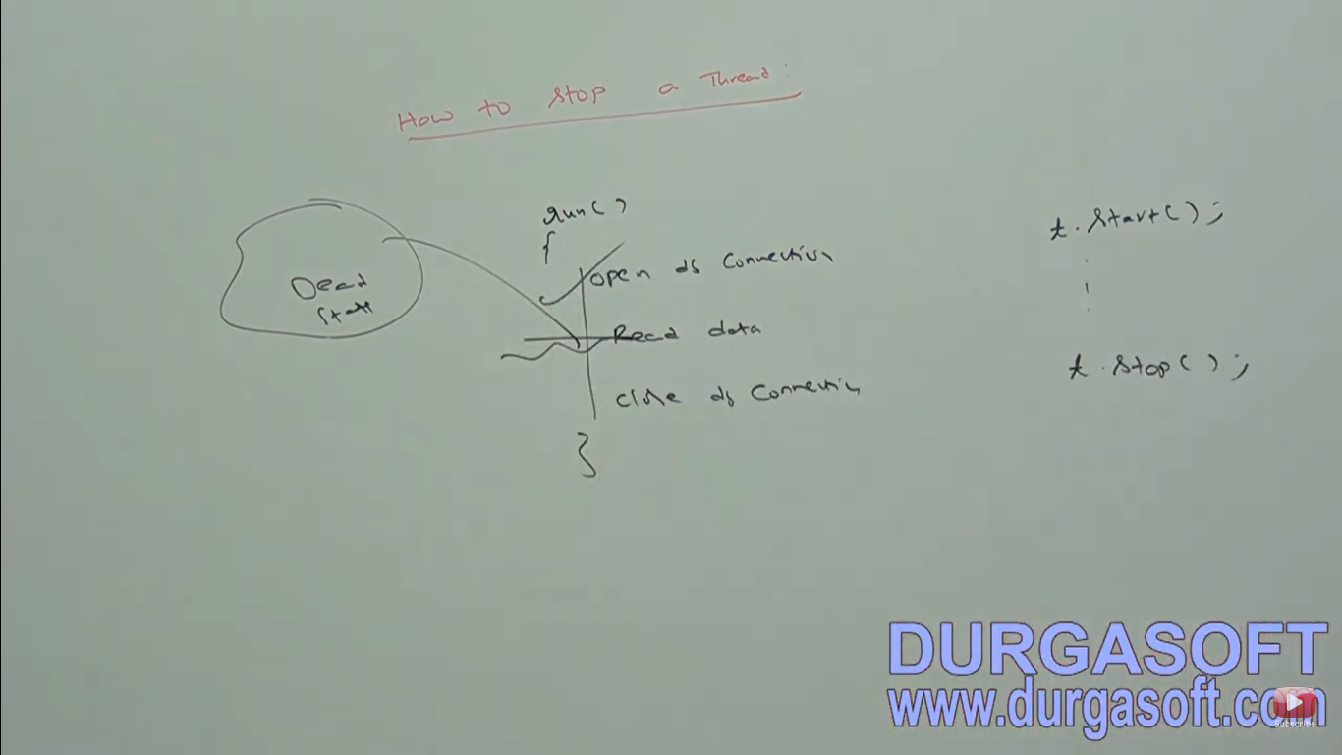

We can stop a thread execution by using stop() method of thread class.

**Public void stop()**

If we call stop() method then immediately the thread will enter into dead state. Anyway stop() method is deprecated and not recommended to use.

**How to suspend and resume of a thread**

Public void suspend()

Public void resume()

We can suspend a thread by using suspend() method of thread class then immediately the thread will be entered into suspended state.

We can resume a suspended thread by using resume() method of thread class then suspended thread can continue it’s execution.

